Name: Bagya Venkatesh
Reg no: 192324263

1. Import the dataset in R. Plot a histogram and density plot for Units_Consumed. Compare
consumption patterns.
2. Using R programming, create a scatter plot between Temperature and Units_Consumed.
Represent Peak_Hours using bubble size. Apply transparency.
3. Using R, calculate average Renewable_Usage for each Sector. Create a bar chart. Interpret
renewable energy adoption.
4. Import Energy_Consumption_Data.csv into Tableau. Create a line chart for monthly energy
usage trends. Create a heatmap (Sector vs Region vs Units). Add filters for Month and
Sector. Design an interactive dashboard.
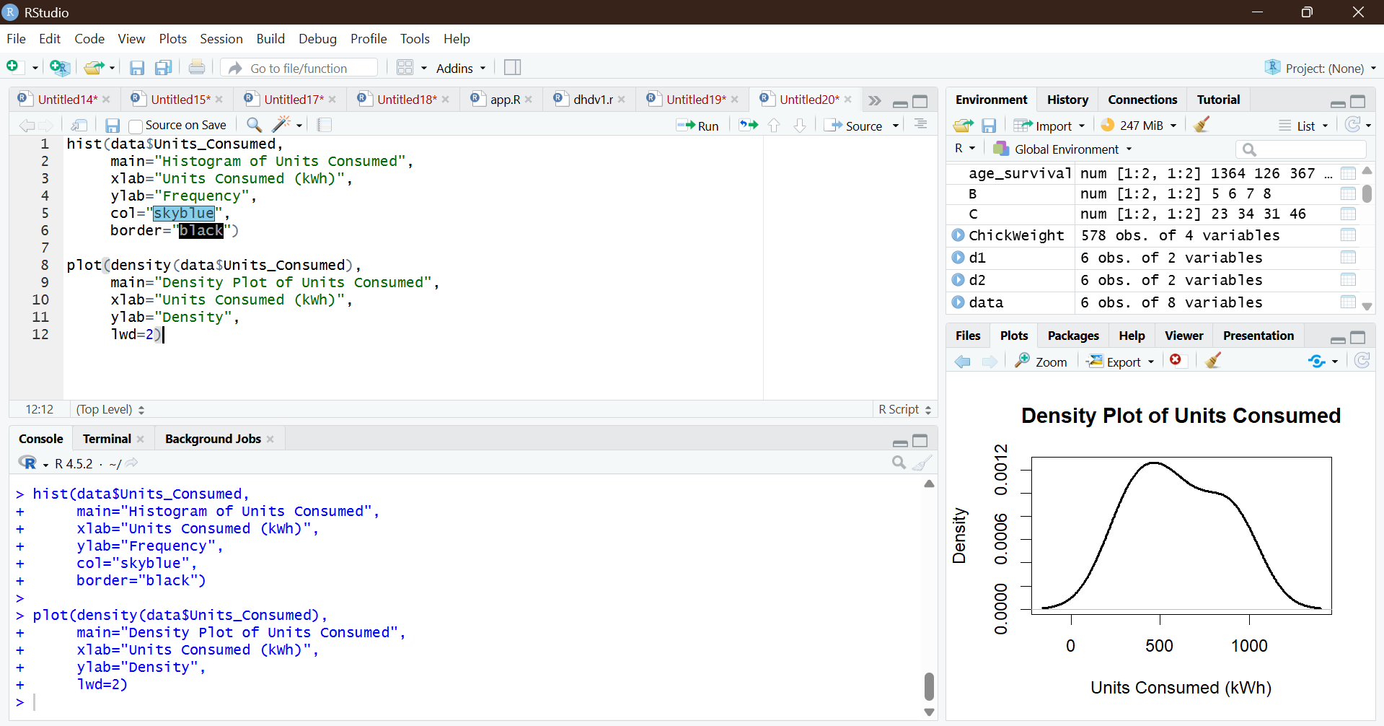

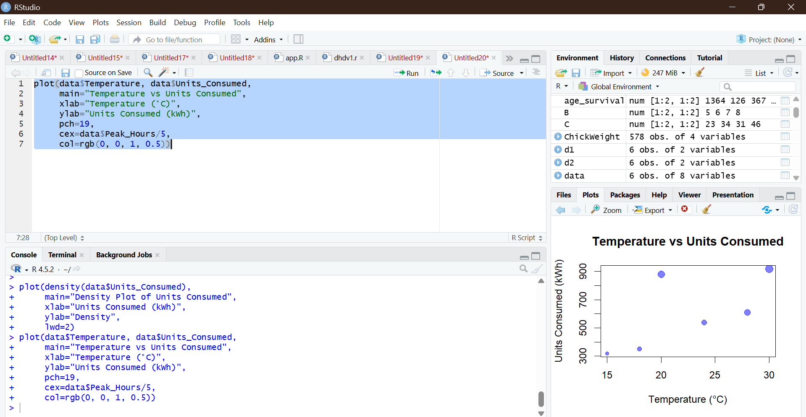
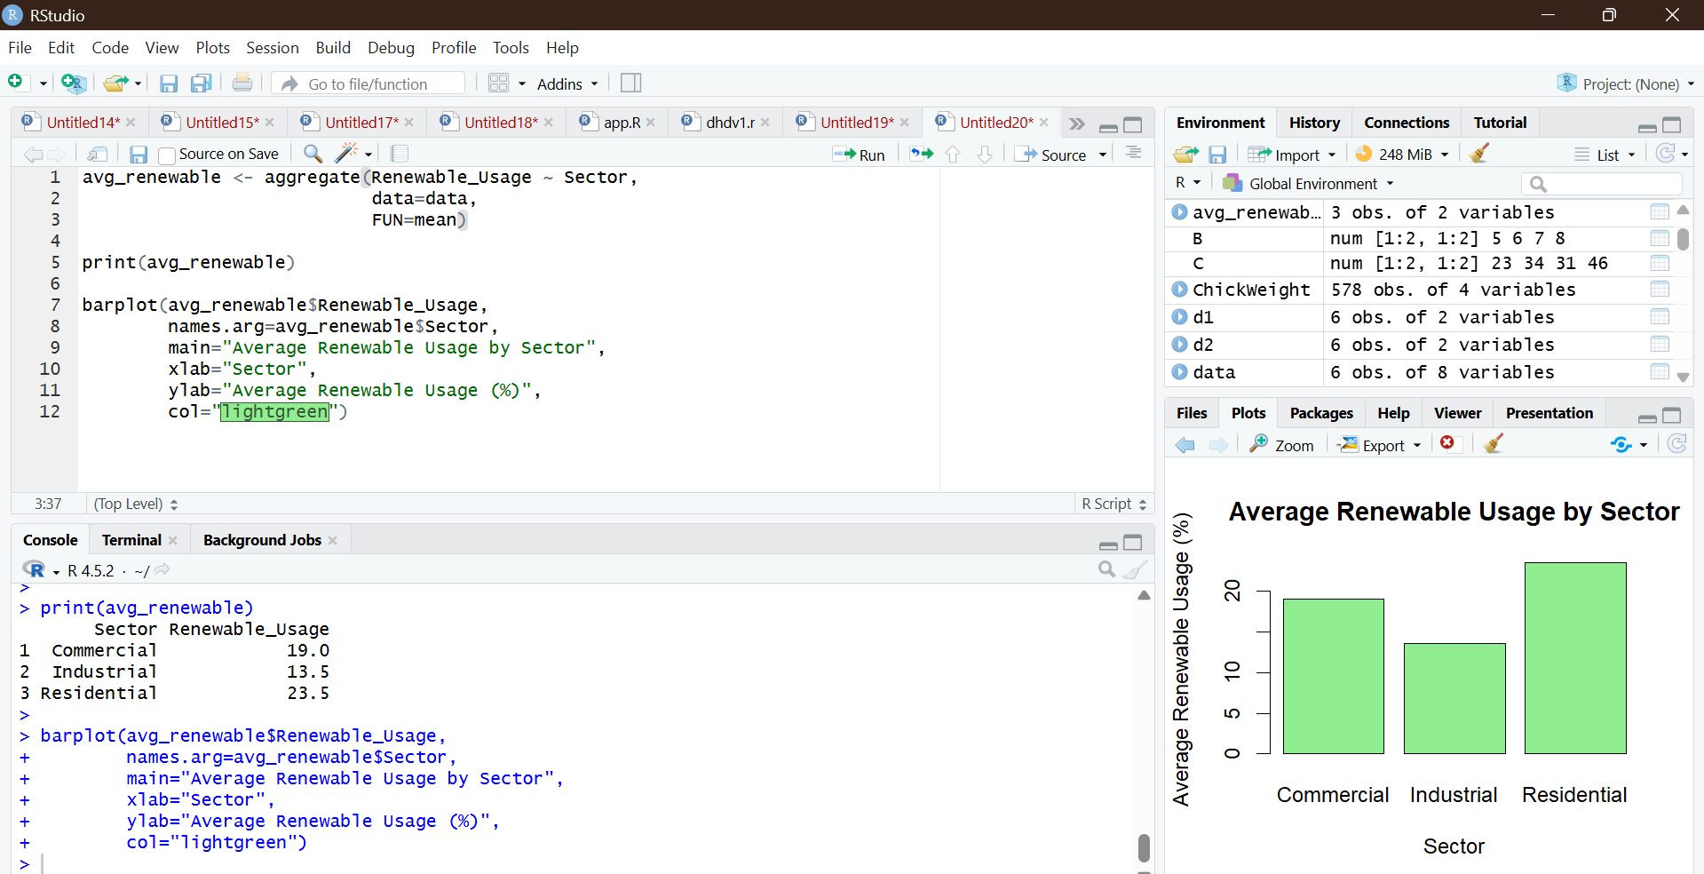
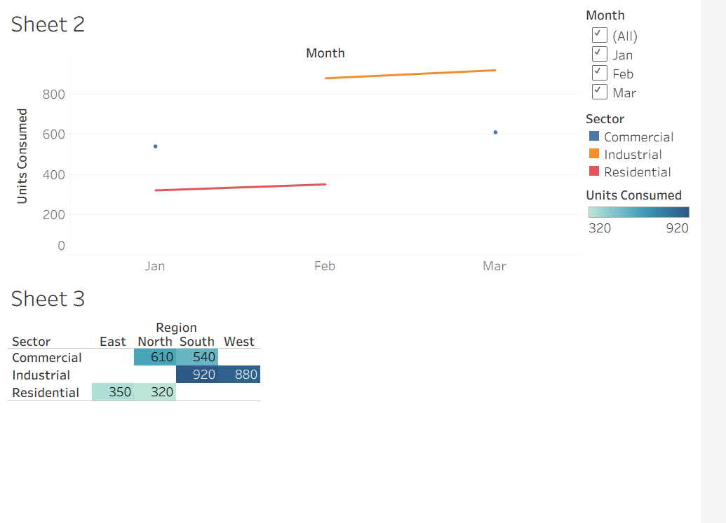
Questions
1. Import the dataset in R. Plot a histogram for Math_Score. Draw a boxplot of Science_Score
by Gender. Add proper title and labels. Interpret the results.
2. Create a scatter plot using R programming between Study_Hours and Math_Score. Use
different colors for Gender. Add a regression line. Explain the relationship between study
time and performance.
3. Using R, convert Exam_Date into Date format. Calculate monthly average Math scores. Plot
a line chart for the trend. Apply moving average smoothing. Identify any increasing or
decreasing pattern.
4. Import Student_Mini_Data.csv into Tableau. Create a bar chart showing average Math
scores by Gender. Create a line chart for score trends over time. Add a filter for Exam_Date.
Design a simple interactive dashboard.
